Decoding lexical semantic information in temporoparietal cortices
Joon Hei Lee¹, Tianhao Lei², Prashanth R. Prakash¹, Robert D. Flint² (?), Matthew C. Tate^{2,4} (?), Joshua M. Rosenow^{2,4,5}, Jason K. Hsieh⁴, Joshua I. Glaser², Marc W. Slutzky^{1,2,3,5}
Departments of Biomedical Engineering¹, Neurology², Neuroscience³, Neurosurgery⁴, and Physical Medicine & Rehabilitation⁵, Northwestern University

Abstract

Introduction
<Background & lit review – taken from quals proposal… will need to edit + condense>
Each year, hundreds of thousands of adults suffer from neurological diseases or injuries such as stroke and traumatic brain injury (TBI), a large proportion of whom eventually develop persistent speech and language deficits. In the United States alone, roughly 795,000 people have a stroke annually1; about two-thirds of acute stroke survivors face communication deficits2, and one-third develop aphasia (which refers to acquired impairment of language production and/or comprehension)3,4. Similarly, clinical series report aphasia in 15–20% of moderate or severe TBIs5. These impairments not only impede cognitive function, but also carry profound functional and psychosocial consequences2. Patients with aphasia consistently report far lower quality of life4, along with high rates of depression and anxiety3,6. Further, communication difficulties compound other stroke sequelae, leading to frustration, social isolation, and reduced access to rehabilitation and care3. There is therefore an urgent need for technologies that restore communication for these individuals.
Recent advances in brain-computer interfaces (BCIs) have made it possible to translate neural signals into meaningful speech output, such as phonemes7 (basic units of speech sounds) or reconstructed speech audio8,9, in highly controlled settings. However, nearly all existing speech BCIs have leveraged signals tied to phonology and articulation found within the frontal lobe—primarily the ventral precentral and inferior frontal gyri7–12. While these systems have demonstrated impressive decoding rates and accuracy in patients with locked-in syndrome13–15 or amyotrophic lateral sclerosis16, who retain intact frontal lobe function, they inherently exclude those with frontal lobe damage. Such individuals, who may experience deficits like expressive aphasia17,18 or apraxia of speech19, cannot generate the frontal lobe signals required to control such BCIs. Consequently, a substantial population of linguistically-impaired patients remains without any viable technology to regain communication function. This constitutes a major clinical gap which further necessitates the development of alternative speech decoding strategies.
Temporoparietal signals encoding semantics could offer an alternate decoding approach. A promising alternative is to circumvent the damaged frontal motor pathways altogether, and decode using semantic information from the temporal and parietal lobes instead. Speech production is generally understood to unfold across multiple processing stages, starting with conceptual preparation and ending in articulation20–23. Lexical-semantic processing—the mapping of conceptual intent onto specific word forms57—is a particularly tractable and ecologically relevant decoding target. Words are the primary currency of human communication, and decoding them directly from neural activity offers rapid and interpretable speech outputs41,58,59 without requiring reconstruction of full sentences or lower-level articulatory signals. Directly decoding these lexical-semantic representations from neural signals could thus serve as a more natural, efficient, and effective method of speech restoration.
Current literature indicates that the neural substrate of semantic processing is not confined to the frontal cortex, but distributed widely across an interconnected frontal-temporal-parietal network26–29. Within this network, several regions within the temporoparietal cortex have been implicated as key semantic hubs, such as the middle temporal gyrus26,32 (MTG), fusiform gyrus34 (forseth, Woolnough) (FG); anterior temporal lobe35 (lambon ralph) (ATL); and inferior parietal lobule26 (IPL) consisting of the supramarginal and angular34,36,37 gyri (SMG/AG). These findings imply that even if a patient’s ability to articulate speech is compromised due to frontal lobe damage, information related to the concepts they intend to convey is potentially still retained in temporoparietal cortices.
Despite the potential of this approach, there is still a gap in our understanding of whether these higher-order semantic representations can be mapped to the specific words one intends to say. Most studies exploring semantics to date have typically characterized neural responses averaged across entire experimental blocks or conditions26,34,38–40, rather than resolving the word-level semantic signals that a decoder must operate on. Moreover, many of these studies utilize speech perception or comprehension25,31,41 paradigms as opposed to speech production, making them suboptimal benchmarks for decoding intended speech. Consequently, it remains unclear whether the semantic representations identified in these contexts are sufficiently consistent and discriminable on a trial-by-trial basis to support reliable word-level decoding during production.
While a small number of studies have decoded semantic information from electrophysiological or neuroimaging data, these efforts remain limited along three axes that are each critical for a speech BCI. First, granularity: existing intracranial and imaging work has resolved only two to three broad semantic categories, or coarse positions within a semantic vector space, stopping well short of the word-level distinctions a communication device must make. Second, modality and task: most demonstrations rely on perception, reading, or imagined speech rather than overt production, and few isolate temporoparietal cortex as the decoding source, leaving open whether a frontal-independent, production-based semantic signal is discriminable trial-by-trial. Third, confounds and extensibility: a decoder trained on a single task with a fixed label set cannot, on its own, distinguish genuinely linguistic representations from co-varying perceptual features of the stimulus, nor can it generalize to words or tasks outside its training set—the regime a clinical BCI must ultimately operate in.
Here we address these gaps using high-resolution electrocorticography (ECoG) and stereo-electroencephalography (sEEG) recordings from temporoparietal cortex during overt picture naming and naming to auditory description, and we make four advances. First, we decode lexical-semantic information at the level of individual words and six semantic categories—a granularity not previously demonstrated—by mapping high-gamma population activity onto continuous word-embedding spaces and reading out word identity by nearest-neighbor retrieval. Second, we show that the decoded representation is modality-independent: the same semantic structure is recovered during picture and auditory naming, the two tasks' neural subspaces share a near-parallel leading direction (mean smallest principal angle 26.5°), and a single decoder co-trained on both performs above chance on each. This provides a decoding-based, trial-by-trial demonstration of an amodal semantic code during production that complements lesion, stimulation, and perception evidence for an amodal hub. Third, we dissociate linguistic from perceptual contributions by contrasting language-only and vision-only embedding models, and find that decoded picture-naming information is better explained by linguistic than by visual structure. Fourth, because our decoder regresses onto a shared, pretrained semantic space rather than classifying a closed label set, it is naturally extensible to new words and tasks—a property we argue is essential for a clinically useful semantic BCI. Together these results establish the empirical and methodological foundation for a semantics-based speech BCI that targets temporoparietal cortex and could serve patients with frontal-lobe damage.

Info on amodal semantic hub (should this be in intro or discussion?): An amodal semantic hub is real but graded: rTMS to either temporal pole disrupts word and picture semantics equally (Pobric 2010), ventral ATL responds to words/pictures/sounds alike while superior ATL is auditory-specific (Visser 2011), and RSA finds shared word/object structure only in parts of LpMTG/AG/IPS with LIPS truly modality-invariant (Devereux 2013). ECoG of visual vs auditory naming (Nakai 2019) shows they start in different sensory cortex and differ in timing/prefrontal profile but converge on a shared left-dominant network before speech onset. Cross-modal semantic decoding is feasible and largely shared across cortex (Tang 2025), and simple resampling fixes imbalance without overfitting (Buda 2017)

Results
Modality-independent, above-chance decoding of semantic category and word identity
- Peak pre-voice accs using all TP electrodes * [PN/category, PN/word, AN/category]
- Accs across time offsets using all TP electrodes * [PN/category, PN/word, AN/category]
Several temporoparietal subregions contribute most to lexical-semantic decoding
- Peak pre-voice accs by ROI * [PN/category, PN/word, AN/category]
- Visualization on cortical surface maps of ROI-level and single-electrode decoding
Tracing passage(?) of decodable lexical semantics across subregions
- Acc heatmaps of time x ROI
Lexical-semantic representations are (dynamic/static?) in temporoparietal cortices
- Train vs test heatmaps + diagonal plots, for a selection of ROIs – good if there are a few more dynamic and more static ROIs
Toward an extensible semantic decoding framework
- Alec’s work using the regression/retrieval -based decoding
- Demonstrate how this retrieval accuracy could be better choice for a generalizable decoding
A regression-and-retrieval decoder recovers word identity and supports zero-shot extension
To move from category-level classification toward an extensible word-level decoder, we replaced the fixed-class classifier with a regression-and-retrieval model. For each participant and time bin, a kernel partial-least-squares (PLS) regressor (Nystrom-approximated RBF kernel followed by PLS with ten latent components; Methods) mapped the high-gamma feature vector onto a continuous word-embedding space, and the predicted embedding was decoded by nearest-neighbor retrieval against a vocabulary database. Across the picture-naming cohort (n = 12), both readouts were significant across 20 (category) and 19 (word) consecutive 100-ms bins (GloVe; FDR q < 0.05) and peaked in the same bin, at an independent category balanced accuracy of 0.29 ± 0.02 (chance 0.167) and a word balanced accuracy of 0.047 ± 0.007 (permuted-label baseline 0.014; mean ± s.e.m. across participants; Fig. R4). Because the decoder predicts a point in a shared semantic space rather than selecting among a closed set of labels, new words can be added to the retrieval database without any retraining or additional neural data, and predictions degrade gracefully toward semantically related neighbors rather than failing categorically.
This flexibility did not reduce category-level performance. Benchmarked against a conventional fixed-class classifier trained on the same participants to decode the six semantic categories directly (a support-vector machine; collaborator analysis), the regression-and-retrieval decoder reached an independent category balanced accuracy of 0.29 (chance 0.167) versus XX for the classifier—a difference of XX in balanced accuracy—and both decoders peaked in the same time bin. The two approaches therefore recover the same category-level information with the same peak timing, yet only the regression-and-retrieval decoder additionally resolves word identity and supports open-vocabulary, zero-shot extension (see Discussion).
A single decoder co-trained on both tasks generalizes across modalities and highlights amodal electrodes
We next asked whether one decoder could serve both speech tasks. For each participant who performed picture and auditory naming, we pooled the trials of both tasks and trained a single kernel-PLS semantic regressor; because picture-naming trials outnumbered auditory-naming trials, the auditory trials were upsampled so that the two tasks contributed equally to the pooled training set (Methods). The co-trained decoder performed above chance on held-out trials of both tasks (independent category balanced accuracy, mean ± s.e.m. across participants: picture 0.241 ± 0.015, auditory 0.251 ± 0.015; chance 0.167; n = 6), retaining 78% (picture) and 87% (auditory) of the within-task decoder's category balanced accuracy; the reduction relative to the per-task decoders was 0.07 (picture) and 0.04 (auditory) in balanced accuracy (Fig. R3a, Table R1). A single model can therefore decode semantic category from either modality without task-specific retraining. Interrogating the co-trained model localized the signal: the PLS variable-importance-in-projection (VIP) score assigns each electrode a weight reflecting its contribution to the shared semantic mapping, and VIP exceeded 1 (above-average importance) for 36.1% ± 6.3% of electrodes per participant (range 28.9–43.9%), defining a subset of high-importance, task-general electrodes (participant RB: V2, V3, V4, with VIP 1.95, 1.85, 1.45; Fig. R3b). These electrodes—informative for semantic decoding in both tasks—are candidate targets for a future implant and candidate sites of an amodal semantic representation.
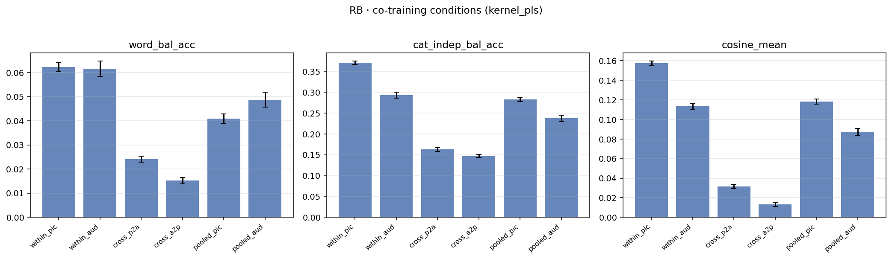
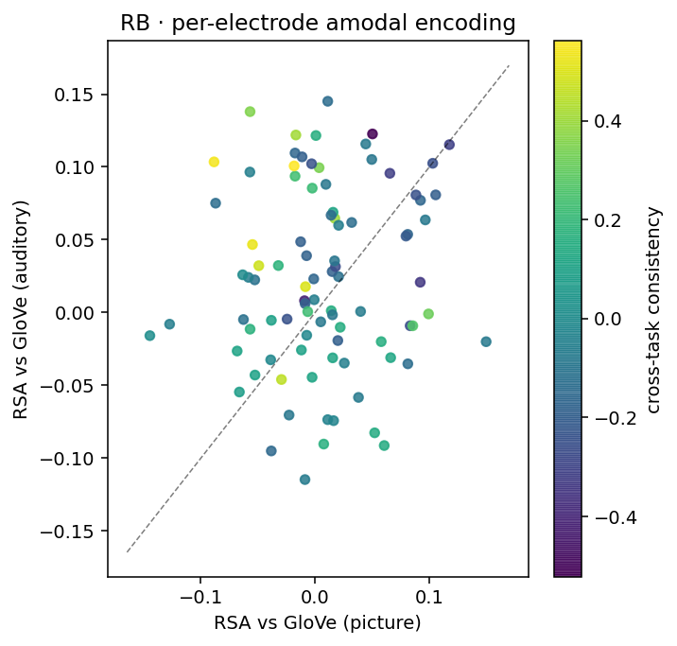
Figure R3 | One decoder co-trained on both tasks generalizes across modalities. a, Decoding metrics for a representative participant (RB) across six conditions: within-task (within_pic, within_aud), cross-task transfer (cross_p2a, cross_a2p), and the co-trained pooled decoder evaluated on each task (pooled_pic, pooled_aud); word balanced accuracy, independent category balanced accuracy, and mean-centered cosine similarity. The pooled decoder stays above chance on both tasks. b, Per-electrode amodal encoding for the same participant: representational similarity to GloVe in the picture task (x) versus the auditory task (y), colored by cross-task tuning consistency; electrodes high and consistent in both tasks are amodal candidates.
Decoder (category balanced accuracy) | Picture | Auditory
Within-task (per-task ceiling) | 0.310 | 0.289
Co-trained, pooled (auditory upsampled) | 0.241 | 0.251
Cross-task (trained on the other task) | 0.183 | 0.180
Chance (1/6) | 0.167 | 0.167

Table R1 | Co-training versus task-specific and cross-task decoding. Group-mean independent category balanced accuracy across the six participants who performed both tasks. The single co-trained decoder (auditory trials upsampled to balance the pool) remains above chance on both modalities (0.241 and 0.251 versus a chance level of 0.167) while retaining 78% (picture) and 87% (auditory) of each per-task ceiling.
Modality-independent semantic representations – i.e. control for perceptual
- A shared subset of ROIs is engaged in lexical-semantic decoding across both tasks – FG, pMTG, pITG …?
- Category retrieval within language vs visual embedding spaces. Decoded semantic information from picture is more likely to be language, instead of vision
Lexical-semantic representations are shared across picture and auditory naming
If the decoded signal reflects abstract meaning rather than task-specific sensory processing, semantic structure should be common to picture naming and naming to auditory description. In the participants who performed both tasks with sufficient overlapping coverage (n = 6), category retrieval at each task's peak bin exceeded chance (1/6 = 16.7%) in every participant (picture, 23.2–39.9%; auditory, 23.6–34.7%; Fig. R2a). The representation also transferred across tasks: a decoder trained on one task and tested on the other exceeded chance in 5 of 6 participants in each direction (train-auditory→test-picture and train-picture→test-auditory), indicating shared decodable content rather than each task being decodable only in isolation. The two tasks' kernel-PLS subspaces shared one near-parallel direction while otherwise diverging: across participants the smallest principal angle between the subspaces was 26.5° on average (range 19.1–37.0°; below 30° in 4 of 6 participants), whereas the largest principal angle was 82.3–89.7° (Fig. R2b), and the first canonical correlation between the task-specific predictions was 0.54 (range 0.44–0.63). Each task's per-word neural geometry was positively but weakly correlated with the GloVe semantic geometry (mean RSA correlation: picture 0.05, auditory 0.05). A single shared leading semantic direction is therefore engaged across modalities, with the remaining structure task-specific.
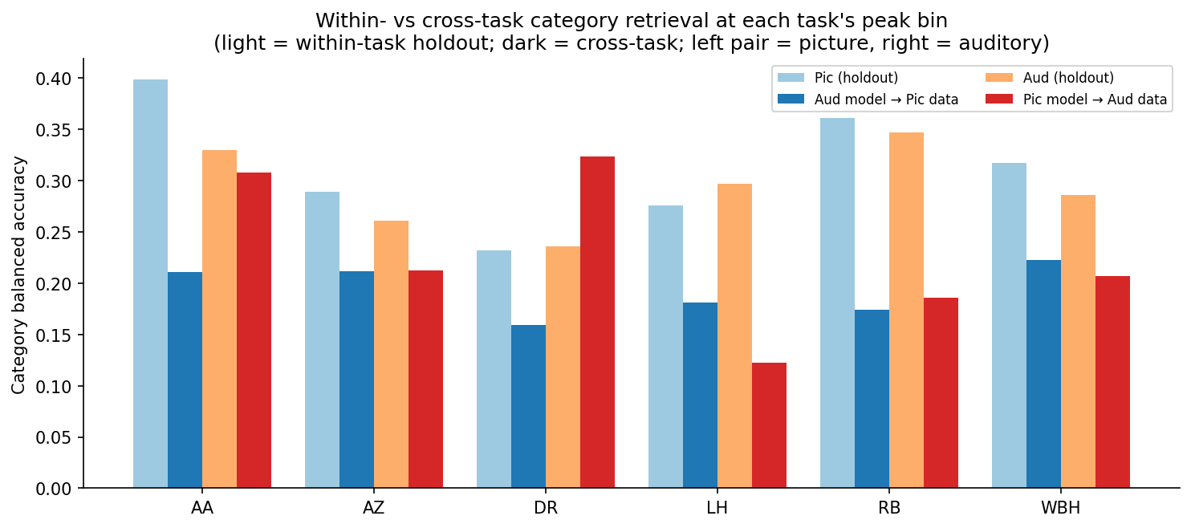
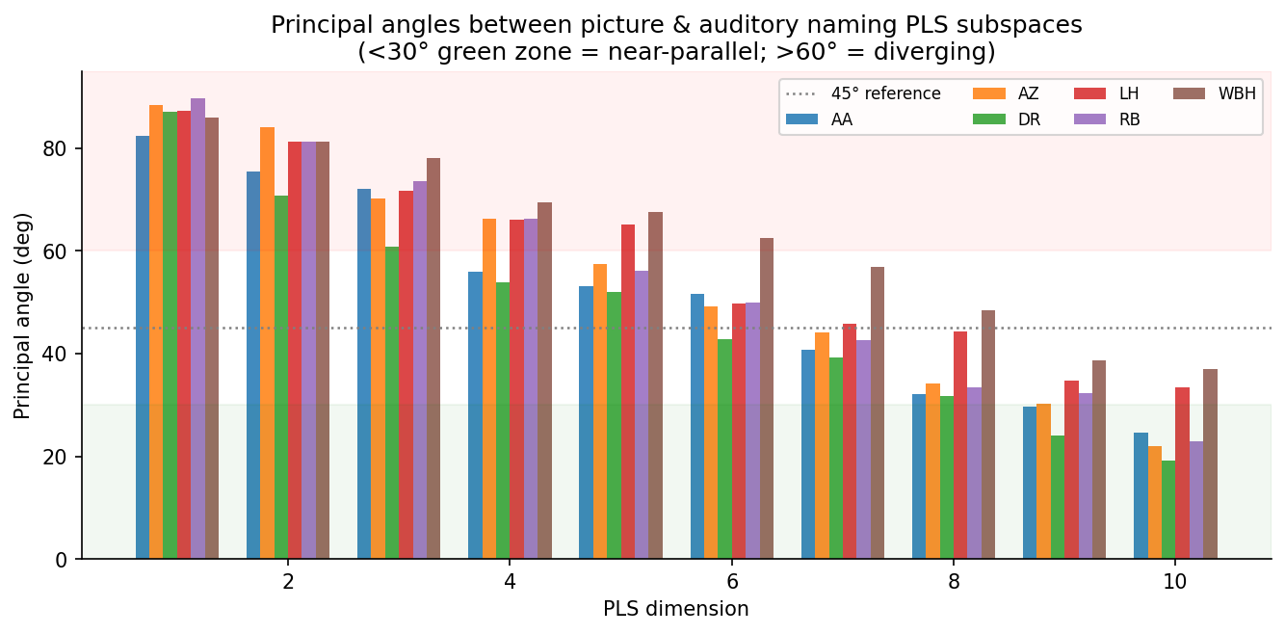
Figure R2 | Semantic representations are shared across picture and auditory naming. a, Category balanced accuracy at each task's peak bin for the six participants who performed both tasks. Light bars, within-task held-out decoding (picture, auditory); dark bars, cross-task decoding (auditory model → picture data; picture model → auditory data); chance = 1/6. b, Principal angles between the picture and auditory kernel-PLS subspaces as a function of PLS dimension; the smallest angle is below 30° in 4 of 6 participants (near-parallel shared direction) while higher dimensions approach orthogonality.
Decoded picture-naming information reflects linguistic rather than visual structure
A central concern for any semantic decoder operating on a picture-naming task is whether it reads out the meaning of the intended word or merely the visual properties of the stimulus. We addressed this directly by regressing high-gamma activity onto two families of embedding model that are, by construction, blind to one another's information: language-only distributional models (GloVe, Word2Vec, ConceptNet), trained purely on lexical co-occurrence, and vision-only self-supervised models (DINOv2, DINOv3, MoCo), trained purely on images with no text or labels. Both families decoded semantic category above chance and followed the same time course, rising after picture onset before returning toward baseline (Fig. R1a). The language models nonetheless carried more decodable information: at the group level the peak above-chance category effect was larger for language than for vision embeddings (GloVe 0.137 [95% CI 0.116–0.158], Word2Vec 0.130 [0.109–0.151], ConceptNet 0.127 [0.109–0.146]; DINOv2-Small 0.117 [0.100–0.135], DINOv3 0.118 [0.099–0.136], MoCo 0.129 [0.109–0.149]), and the language-minus-vision difference was significantly positive in 13 consecutive bins for category accuracy and 1 bin for word accuracy (linear mixed model, FDR q < 0.05). The effect was consistent across the cohort: category decoding favored language over vision embeddings in 11 of 12 participants (Wilcoxon signed-rank p = 0.001) and word-level decoding in 9 of 12 (p = 0.129; Fig. R1b). Decoded picture-naming activity in temporoparietal cortex therefore reflects linguistic-semantic structure more than visual-perceptual structure, consistent with read-out from a post-perceptual, lexical-semantic stage rather than from visual processing of the stimulus.
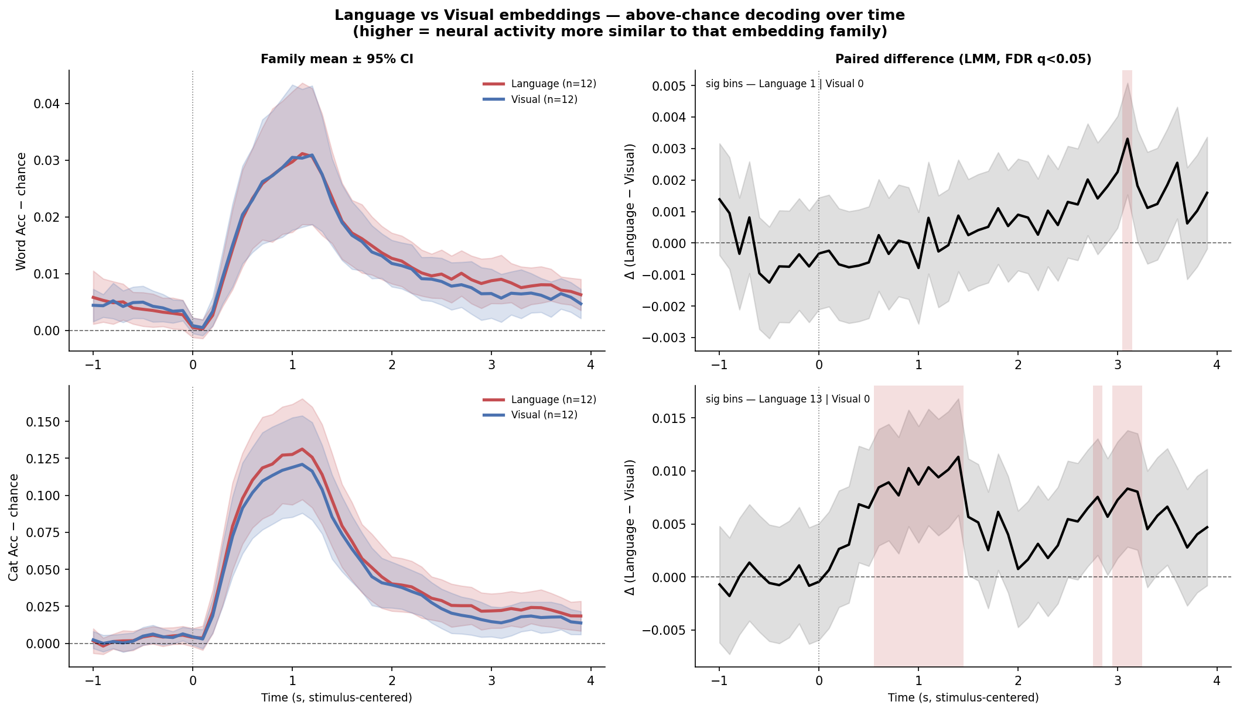
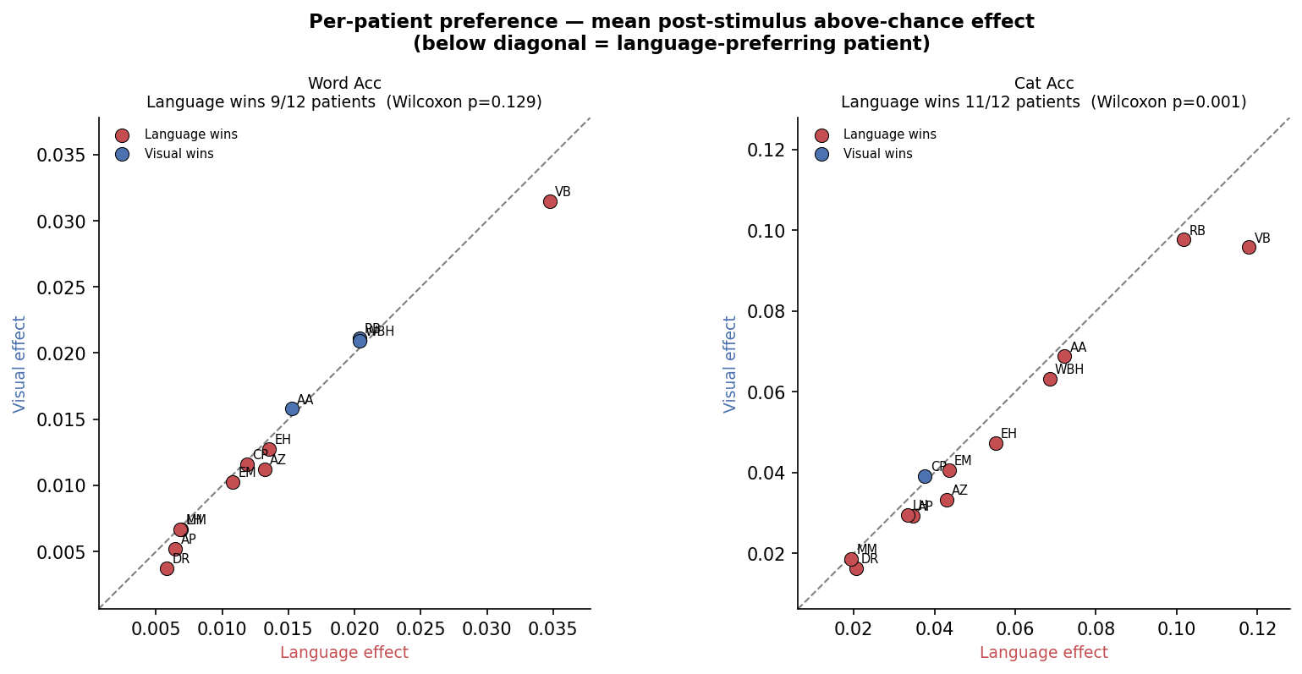
Figure R1 | Decoded picture-naming information is better explained by language than by vision. a, Above-chance decoding over time for language (red) and vision (blue) embedding families (family mean ± 95% CI across 12 participants), for word accuracy (top) and category accuracy (bottom). Right panels show the paired language-minus-vision difference; shaded bins are significant (linear mixed model, FDR q < 0.05). b, Per-participant comparison of the mean post-stimulus above-chance effect for language (x) versus vision (y) embeddings; points below the diagonal are language-preferring. Language is favored in 11/12 participants for category accuracy (Wilcoxon p = 0.001) and 9/12 for word accuracy (p = 0.13).

Discussion
Despite several cortical regions being proposed as possible substrates for semantic processing, mapping activity from these areas to specific speech output remains generally underexplored. Our study bridges this gap by demonstrating lexical-semantic decoding across a picture naming and auditory description naming task.
By performing decoding across 6 semantic categories and 15 individual words, we achieved a level of decoding granularity that has not been demonstrated to date, and which lends well to a future lexical-semantics-based speech BCI.
We characterized the spatiotemporal dynamics of decoding within temporoparietal cortices. Contributing subregions we identified will help narrow down potential implant targets for a semantic BCI, while the temporal profile of decodable semantic signal—including how dynamically it varies over time—could inform temporal feature extraction approaches in such systems. Moreover, decoding accuracy was significantly above chance prior to vocalization, which shows that […]
Critically, lexical-semantic decoding remained consistently above chance across both speech tasks, with XX, YY and ZZ emerging as common loci for decoding. This suggests that we were indeed decoding information related to semantics rather than perception of task-specific stimuli, and that these representations arise from modality-convergent semantic hubs. (tie to mid-Fus, pMTG etc. in Forseth et al)
Category decoding accuracy during the picture naming task was also better accounted for by language rather than visual embedding spaces, further indicating that the decoded signals represented linguistic meaning and not simply processing of visual stimuli.
Our cross-task results speak to a long-standing question about the organization of semantic memory. Convergent evidence from stimulation, lesion, and perception studies has argued for a graded amodal semantic hub in which word and picture meanings converge: repetitive TMS to either temporal pole disrupts word and picture semantics comparably (Pobric et al., 2010), the ventral anterior temporal lobe responds to words, pictures, and sounds alike whereas superior temporal regions are auditory-specific (Visser & Lambon Ralph, 2011), representational-similarity analyses find shared word/object structure in parts of left pMTG, angular gyrus, and intraparietal sulcus (Devereux et al., 2013), and the mid-fusiform behaves as a heteromodal naming hub (Forseth et al., 2018). ECoG of visual versus auditory naming shows that the two modalities begin in different sensory cortices and differ in early timing but converge on a shared, left-dominant network before speech onset (Nakai et al., 2019). Our findings extend this picture within a decoding framework and during overt production: not only is semantic category decodable from temporoparietal cortex in both picture and auditory naming, but the representations are geometrically aligned, a single co-trained model transfers between them, and the VIP analysis nominates specific electrodes that carry semantic information in both tasks. This is positive, trial-by-trial evidence that the signal a temporoparietal semantic BCI would exploit is modality-independent—an essential property if such a device is to generalize beyond the particular task used to calibrate it. Recent work decoding semantics across participants and stimulus modalities (Tang & Huth, 2025) similarly supports modality-general semantic decoding, though largely in comprehension; our results provide the production-side counterpart.
A further advantage of our approach is extensibility, which we argue is decisive for a clinically useful semantic BCI. A conventional classifier learns decision boundaries over a fixed set of K words; its output space cannot represent any word outside the training set, so enlarging the vocabulary requires collecting new labeled neural data and retraining the model for every word added—an impractical demand when labeled intracranial data are scarce and costly. A regression-and-retrieval decoder instead predicts a point in a continuous, pretrained semantic space and reads out by comparison to a vocabulary database. New words are incorporated simply by adding their embeddings to that database at inference time, with no neural data and no retraining (zero-shot extension), so decoder capacity is decoupled from vocabulary size. The same property yields three further benefits: errors are semantically graceful, falling on near-neighbors of the target rather than on arbitrary classes; the shared target space supports transfer across tasks and, in principle, across participants, as we demonstrate with a single decoder co-trained on picture and auditory naming; and the decoder can exploit the rich structure of modern embedding spaces rather than treating words as exchangeable labels. The principal limitation is that retrieval accuracy is bounded by how faithfully the chosen embedding space reflects the brain's semantic geometry and by how linearly the neural code maps onto it; improving these mappings—and validating zero-shot extension on held-out words—is an important direction for translation. For restoring open-ended communication, where the usable lexicon must grow over time, this extensibility makes regression-and-retrieval a more generalizable foundation than fixed-class decoding.
Limitations/Future work
Study recruited language-intact pts – investigate decoding in aphasic population a la Tang 2026
Still a controlled expt setting – naturalistic speech a la Pescatore 2025
Moving from word-level to sentential/compositional outputs

Methods
We decoded semantic information from intracranial high-gamma activity using a patient-wise regression framework that mapped neural population responses onto continuous word-embedding spaces. Analyses were performed separately for each patient and task, with the cohort automatically defined by the presence of task-specific data files in the repository. Trial-wise preprocessing removed poor-quality trials and channels, and neural activity was binned at 100 ms resolution. At each decoding time point, the model used a temporally lagged neural feature vector comprising the current bin and the preceding nine bins, thereby capturing 1 s of recent neural history. For auditory naming, the pipeline further supported behavioral-event alignment and linear warping of the auditory stimulus period to normalize across variable stimulus durations.
Semantic targets were defined using lemmatized lexical labels and included both text-based and visual embedding models. The default decoder used kernel partial least squares, implemented as a Nyström approximation of an RBF kernel followed by partial least squares regression with 10 latent components, trained over 50 repeated random train-test splits. Model performance was assessed on held-out trials using both continuous and retrieval-based metrics. In addition to explained variance, we quantified the directional agreement between predicted and true embeddings using mean-centered cosine similarity, a measure designed to remove inflation arising from the shared centroid of the embedding space.
To assess lexical and semantic recovery, predicted embeddings were decoded by nearest-neighbor retrieval against a vocabulary-level embedding database. Word-level performance was quantified using exact top-k retrieval and macro-balanced accuracy. Category-level performance was quantified both by mapping the retrieved word to its category and, more stringently, by assigning each predicted embedding directly to the nearest category centroid in embedding space. This independent category metric provides a category-level readout that is not contingent on successful lexical decoding and therefore offers a more direct estimate of abstract semantic structure in the neural signal.

Study participants
All research activities were conducted under the oversight of the Northwestern University Institutional Review Board and in full compliance with Northwestern University ethical guidelines. Study participants were individuals already with intracranial electrode implantation as part of their clinical epilepsy monitoring. Electrode placement was dictated entirely by clinical requirements for seizure localization and was not modified in any way to accommodate research objectives.
Research enrollment was considered only after a patient had had the electrodes implantation and been independently consented to the study. Prospective participants were evaluated against the following inclusion criteria: age 18 or older, right-hand dominance, sufficient cognitive and language production capacity to provide informed consent, and fluency in English. All enrolled participants provided written informed consent and retained the right to withdraw at any time without any impact on their clinical care. A total of 12 participants were enrolled in the study. No participant blinding or randomization procedures were employed.
Participants received standard clinical ECoG arrays (1 cm interelectrode spacing and 2.3 mm electrode diameter) or combined with depth electrodes (patient xxx). Electrode localization was performed by manually identifying contacts over the temporal and parietal lobes using co-registered preoperative MRI and postoperative CT imaging (see Co-registration below). For participants xxx, any depth electrode contacts determined to lie within white matter were excluded from subsequent analyses.
Co-registration of electrodes
Data acquisition
Neural signals were continuously recorded and digitized at 2 kHz using a Nihon Kohden system. Line noise was attenuated via notch filtering at 60 Hz and its harmonics, after which signals were bandpass filtered between 70–200 Hz using a causal linear-phase finite impulse response (FIR) filter. To correct for the constant group delay introduced by the filter, a fixed time shift was applied to realign the filtered signals with the original time base. High gamma activity (HGA) was used as the instantaneous power of the analytic signal, computed by squaring the amplitude envelope of the Hilbert-transformed filtered signal. Common average referencing was applied across all electrodes within each shank to attenuate shared noise. The resulting power time series were subsequently downsampled into non-overlapping 100 ms bins. For analyses requiring linear time warping, temporal interpolation or downsampling was performed prior to binning. Artifact rejection and electrode exclusion were conducted through iterative manual inspection of trial-averaged, electrode-averaged, single-trial HGA, and both single-trial and trial-averaged spectrograms. Electrodes or trials exhibiting excessive noise, epileptiform activity, or other artifacts were excluded from all subsequent analyses. Additional non-language shanks are manually excluded for LH and RB. (Should we talk about details of the how we manually remove things?)
Speech task
All 12 participants performed a picture naming task; a subset (n=7) of them additionally performed a naming to auditory description task (visualization of these should be in the results?). The picture naming task consists of 1.5 second of display of the picture, followed by a 2.5 s display of a green dot with black background that serves as a go cue. The patient was instructed to use one word to describe the object/scene in the picture and to say the word out loud. If the patient did not recognize the picture, they are instructed not to say anything. There is no inter-trial interval. The naming to definition task consists of an auditory description of an object/scene that lasts between 5-8 s with a fixation cross on the screen, followed by a 2.5 s display of a green dot with black background.
Linguistic materials
Language embeddings. We used two established distributional-semantic models that derive word meaning exclusively from lexical co-occurrence statistics, with no visual input. GloVe (Global Vectors for Word Representation; Pennington, Zinkov & Socher, 2014) was trained on the 840-billion-token Common Crawl corpus, yielding 300-dimensional vectors whose geometry encodes semantic similarity via log-bilinear co-occurrence statistics. Word2Vec (Mikolov et al., 2013) was trained on the Google News corpus (~100 billion words) using the skip-gram with negative sampling objective, also producing 300-dimensional vectors. Though both models produce similar-dimensional representations, they differ in training corpus and objective: GloVe directly factorizes a global co-occurrence matrix, whereas Word2Vec optimises local context-prediction. These models capture distributional-semantic structure—words that appear in similar linguistic contexts cluster together—but are entirely blind to the visual appearance of their referents.
Vision embeddings. We selected two self-supervised vision models that learn image representations without any language supervision, ensuring that explained neural variance cannot be attributed to implicit linguistic content. DINOv2-Small (Oquab et al., 2024) is a Vision Transformer trained with a self-supervised distillation objective (self-distillation with no labels) on the curated LVD-142M dataset. We extracted the CLS token from the final transformer layer, yielding a 384-dimensional embedding per stimulus image. MoCo (Momentum Contrast; He et al., 2020; Chen et al., 2021) uses a ResNet-18 backbone pre-trained with the MoCo-v2 self-supervised contrastive learning framework on the YFCC100M dataset (~100 million Flickr images) and subsequently fine-tuned on ImageNet-1k for feature refinement. We extracted the 512-dimensional embedding via global average pooling of the final convolutional stage. Both vision models were deliberately chosen to be language-free: neither DINOv2 nor MoCo incorporates text, captions, or class labels during representation learning. Any neural variance uniquely explained by these embeddings therefore reflects visual-perceptual rather than linguistic information.
The word set used for both picture naming and naming to definition tasks include words from six manually classified semantic categories (see supp table xxx, should we include the full word set?). For participant xxx, an older version of word set was used that included slightly different word categories (see supp table xxx). The words were inspired by Jeff Binder lab (Bill Gross), Neuropsychic clinical word set, and Flinker word 50. Each semantic categories comprise 10 words. Words were chosen to satisfy (1) no more than 3 syllables, (2) balanced first phoneme per category, (3) word population span the word embedding space constructed by the first 3 principal components of their GloVe vectors. Images for the picture naming task were colored photos from Google search.
Neural feature extraction
For the picture naming task, trials are truncated to the shortest common duration and analyzed on a shared stimulus onset timeline. For the auditory naming task, the stimulus segment is linearly warped to the median stimulus duration across trials, and truncated to the shortest common duration counting from stimulus offset. At each decoding time bin, the neural feature vector is formed by concatenating the current bin with the preceding 9 bins (in total 10 bins, 1 second) across all retained channels. Individual decoding models are built at every decoding time point.
Neighborhood Components Analysis
A key challenge in neural decoding is identifying a putative low-dimensional subspace containing neural activity most informative for the target variable48–50, particularly given the high dimensionality and inter-part icipant variability of ECoG/sEEG recordings51,52. To address this, we applied neighborhood components analysis53 (NCA)—a supervised dimensionality reduction technique that directly optimizes a distance metric to maximize leave-one-out classification accuracy in the projected space—to extract the neural feature dimensions most discriminative for semantic categories and word identity prior to decoding. Unlike unsupervised approaches such as principal component analysis54 (PCA), NCA preserves and amplifies class-relevant structure in the data53,55, making it particularly well-suited for decoding tasks where the relevant signal is sparse across the full feature space56. We determined the optimal number of embedding dimensions empirically by training and evaluating classifiers across a range of dimension counts (5-50) in a pilot subset of 3 participants. The dimensionality at which held-out decoding accuracy plateaued (15) was then uniformly applied to all remaining participants. The NCA-transformed features served as input to all subsequent classifiers.
Classification task
We performed decoding at two different granularities of lexical-semantic information: (i) semantic category and (ii) word identity. For each participant, we divided HG features across all trials into training (80%) and testing (20%) datasets. We trained and evaluated support vector machine (SVM) classifiers with radial basis function (RBF) kernels72 using 5-fold cross-validation within the training set, optimizing decoder hyperparameters via a grid search to maximize validation accuracy. We then retrained the best-performing model configuration on the full training subset, and tested on the held-out test set. We repeated this process over 10 randomized stratified k-fold partitions to yield a stable estimate of mean test accuracy. To assess statistical significance, we compared observed test accuracy to an empirical chance distribution derived by running the decoder on label-shuffled test sets 200 times.
Spatial characterization of lexical-semantic decoding
Region of interest specification and decoding
We assigned recording electrodes to anatomical regions of interest (ROIs) based on electrode coordinates derived from the above co-registration process. For each participant with sufficient coverage (≥3 electrodes) in a given ROI, we trained and evaluated separate SVM classifiers using only electrodes within that ROI. We then computed mean decoding accuracies across participants to yield group-level estimates, from which we identified the ROIs contributing the most to lexical-semantic decoding.
Single-electrode decoding
To corroborate and complement ROI-level analyses, we also performed decoding using individual electrode features. We projected single-electrode accuracy values onto participant-specific cortical surface reconstructions, and subsequently normalized them to a common brain surface for group-level visualization.
Temporal characterization of lexical-semantic decoding
Decoding through time
To identify the time course of decodable lexical-semantic information, we evaluated decoders using HG features extracted at varying time offsets relative to stimulus presentation, using a 500-ms sliding window of data across the trial duration. For each time offset, we computed a p-value using the permutation test described above, and thereafter corrected p-values across all offsets for false discovery rate (FDR) using the Benjamini-Hochberg method73. We plotted decoding accuracy as a function of time to establish when semantic information became reliably decodable and when it peaked prior to speech onset.
Temporal generalization
Explain the train time vs test time matrix setup, and what it tells us. Remember to cite JRK here
Regression model
We used a two-stage pipeline consisting of a Nyström approximation of the radial basis function (RBF) kernel followed by partial least squares (PLS) regression with 10 components. The Nyström step approximates the RBF kernel mapping by computing kernel evaluations between each training sample and a random subset of 100 training observations (sklearn default), projecting the neural features into a 100-dimensional nonlinear feature space. PLS regression then identifies 10 latent components that maximize the covariance between the kernelized neural features and the full-dimensional embedding targets. Critically, PLS performs implicit dimensionality reduction on both sides of the mapping simultaneously: it extracts linear combinations of the input features and linear combinations of the target dimensions that are maximally covariant, without requiring a separate compression step on the embedding targets. This kernel PLS approach combines the capacity to capture nonlinear neural-to-semantic mappings with robustness to the high-dimensional, multicollinear structure of multi-channel intracranial data.
Selection of the number of PLS components
The number of PLS latent components governs a bias–variance trade-off: too few components underfit the neural-to-semantic mapping, whereas too many fit training-set idiosyncrasies and generalize poorly. We fixed this hyperparameter by sweeping the component count from 2 to 35 (the range over which all participants and embedding models were comparable) and evaluating held-out performance over repeated train/test splits in seven participants and four embedding models. Held-out mean-centered cosine similarity increased from 0.091 (2 components) to 0.129 (6) and 0.130 (10) and then varied by less than 0.002 through 35 components, and category balanced accuracy increased from 0.273 (2) to 0.339 (10)—within 0.001 of its maximum over 2–35 components (0.340 at 15)—while over the same range the train–test R² gap grew monotonically (0.04 at 2, 0.15 at 10, 0.22 at 15, and 0.27 at 20 components), indicating progressively worse overfitting with no held-out benefit. Apparent gains beyond 35 components arose only in a single participant with extreme training-set overfitting (train R² 0.46–0.57) and were excluded as non-comparable. Ten components captured at least 99% of the maximum held-out cosine similarity and category accuracy observed over 2–35 components while limiting the train–test R² gap to 0.15, and were used for all regression analyses (Supplementary Fig. Sx).
Cross-task co-training and electrode importance
To test whether one decoder could serve both speech tasks, we pooled picture- and auditory-naming trials within each participant who performed both, restricting to the intersection of channels present in both tasks and aligning each task at its own category-decoding peak bin. Because picture trials outnumbered auditory trials, we balanced the pooled training set by random upsampling of the minority (auditory) trials to equal counts before fitting; simple resampling of this kind corrects task imbalance without inducing overfitting in this setting. A single kernel-PLS regressor (ten components, as above) was then trained on the balanced pool and evaluated on held-out trials of each task over repeated bootstrap splits, alongside task-specific (within-task) and transfer (train-one/test-other) decoders sharing the same test folds. Decoding was scored with word balanced accuracy, an independent category-centroid metric, and mean-centered cosine similarity, each split into trials of words seen versus unseen in that model's training set. Electrode importance for the co-trained model was quantified by the PLS variable-importance-in-projection (VIP) statistic, which summarizes each channel's contribution across the retained latent components; channels with VIP > 1 (above-average importance) were treated as the high-importance set, and per-electrode cross-task semantic encoding was additionally assessed by representational-similarity analysis against the embedding geometry computed separately for each task.
Linguistic versus visual attribution
To determine whether decoded picture-naming activity reflected linguistic meaning or visual stimulus properties, we compared regression onto language-only embeddings (GloVe, Word2Vec, ConceptNet) against regression onto vision-only self-supervised embeddings (DINOv2, DINOv3, MoCo) using the identical kernel-PLS pipeline and retrieval metric. For each participant, embedding family, and time bin we computed the above-chance decoding effect relative to the participant's permutation null, and summarized each participant by the mean post-stimulus above-chance effect for the language and visual families. Family preference was tested across participants with a two-sided Wilcoxon signed-rank test (language versus visual effect) for both word and category accuracy. The time-resolved language-minus-visual difference was tested bin-by-bin with a linear mixed model (random intercepts for participant), correcting across bins for false discovery rate. Because the vision models are trained without any text, captions, or labels and the language models without any images, neural variance uniquely captured by each family can be attributed to visual-perceptual versus linguistic-distributional structure, respectively.
Cross-task representational alignment
Shared semantic structure across tasks was quantified at each task's peak bin from the per-task kernel-PLS solutions. We computed (i) cross-task category retrieval, training the regressor on one task and evaluating retrieval on held-out trials of the other; (ii) principal angles between the two tasks' PLS subspaces, with small leading angles (<30°) indicating near-parallel representations; (iii) canonical correlations between the task-specific embedding predictions; and (iv) a representational-similarity analysis comparing the per-word neural representational-dissimilarity matrices of the two tasks to each other and to the GloVe geometry. These analyses were restricted to the words shared between a participant's two tasks.
Cross-validation and permutation null. For each embedding model and each time bin independently, we performed 100 iterations of random train/test splitting (70%/30%). On each iteration, the Nyström kernel approximation and PLS regression were fit on the training set and applied to the held-out test set, yielding predicted embedding vectors for each test trial in the original embedding space. To establish a chance baseline, the training neural features were element-wise permuted (destroying trial-to-feature correspondence while preserving marginal statistics), the full pipeline was re-fit on the shuffled data, and retrieval was evaluated on the same test set. Goodness-of-fit was assessed by the mean cosine similarity between mean-centered predicted and true embeddings.
Word retrieval accuracy
Predicted embeddings were evaluated by retrieval against a vocabulary database. For each unique word in the stimulus set, a single representative embedding was computed as the mean across all trials of that word, yielding a database of W canonical word vectors. For language embeddings (GloVe, Word2Vec), this averaging is trivial: every trial of a target word maps to the same fixed vector, so the mean reduces to deduplication. For vision embeddings (DINOv2-Small, MoCo), each word is depicted by three distinct image variants across trials, each producing a different embedding; the mean therefore averages across these visual depictions, yielding a single image-level representation per word that is not tied to any exemplar. Both the database and the predicted test embeddings were then mean-centered by subtracting the database centroid (the mean across all W word entries), so that retrieval operated on deviations from the average word representation rather than on absolute positions in embedding space. The decoded word for each test trial was assigned by nearest-neighbor lookup under cosine distance in this centered space:
$$ŵᵢ = argmin_{w}\left( 1 -\cos\left( ŷᵢ - μ, ēw - μ \right)\right)$$
where μ is the database centroid, ēw is the mean embedding of word w, and ŷᵢ is the predicted embedding for test trial i. Top-1 word accuracy is the fraction of test trials for which the retrieved word matches the true word identity. Top-3 and top-5 accuracy relax the criterion to whether the true word appears among the 3 or 5 nearest database entries, respectively. Word balanced accuracy is the macro-averaged recall across word classes, $BA =\frac{\left(\frac{1}{C}\right)Σ_{c}TP_{c}}{\left(TP_{c}+ FN_{c}\right)}$ , where C is the number of unique words represented in the test set. Macro F1 is computed analogously across the same word labels.
Category retrieval accuracy
To calculate category retrieval accuracy, the model predicts semantic category by comparing the cosine distance of the predicted embedding to the centroid of different semantic categories in the word embedding space. A centroid is formed from the mean-centered word embeddings, and each predicted embedding is assigned to the nearest category centroid:
$centroid_{c}= average of \left(e_{w}- mu\right)$ over all words w in category c
$cat_{hat_{i}}$ = argmin over categories c of
$$1 - cosine\left( y_{pred_{i}}- mu , centroid_{c}\right)$$
Category accuracy is then computed by comparing cat_hat_i with the true category label. Category balanced accuracy is the macro-average recall across semantic categories, using the same balanced-accuracy definition as above. This is the cleanest category-level measure in the repository because it quantifies category information even when the exact lexical item is not recovered.
Statistical tests
This section is subject to change.

